VI Past simple and past continuous combined in typical sentence structures

----------------------------------------------------------------------------------------------------------------------------------------------------------------------------------------------
a) What was she/he doing when something else suddenly happened ?
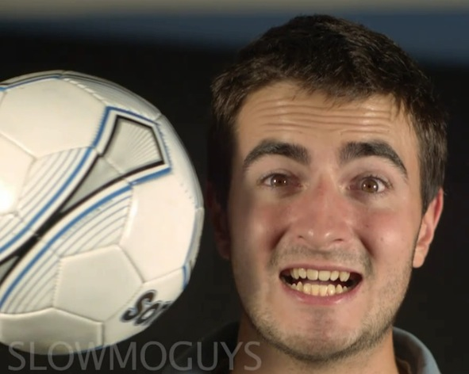
b) What happened when/after the first action happened ?
c) What was happening while sth. else was happening, too? a) / c)
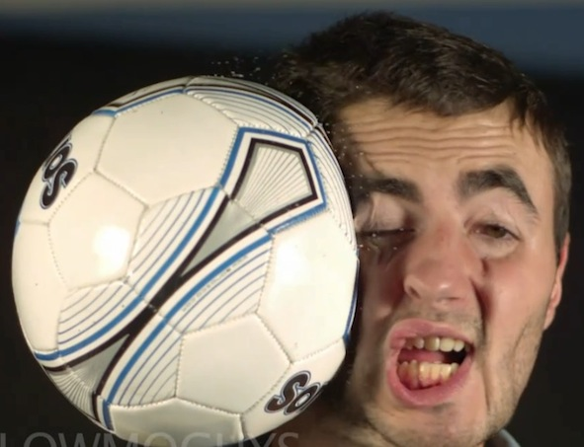
Exs. a) He was (sort of) smiling when the ball hit him.
(26 P) <--->b) He cried out with pain when the ball hit him. b)
or: When the ball hit him, he cried out with pain.
<---> c) He was looking at us while the ball was flying towards him.
----------------------------------------------------------------------------------------------------------------------------
Exercise: Make sentences of these types with the given
language material and pictures:

1 I) hold crab // pinch his nose
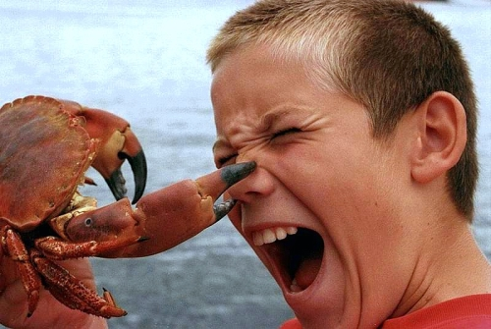

II) crab pinch his nose // he cry out loud

III) crab pinch his nose again and again // he cry out loud

2 I) swim in lake // suddenly a hole open
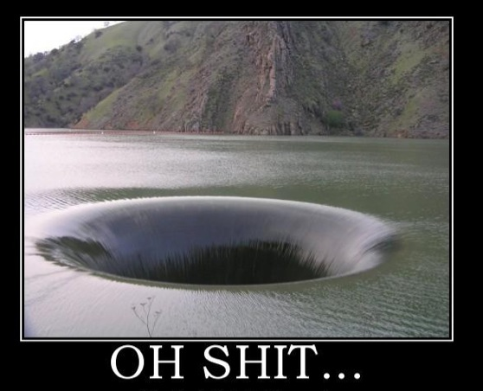

II) swim in lake // a hole slowly open // pull him down

III) a hole open in lake // pull him down
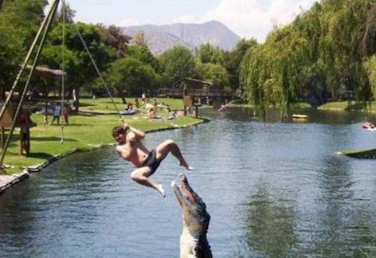

3 I ) kids play at river bank // crocodile jump up

II) boy swing over the river // crocodile jump up all the time

III) crocodile jump up // boy try to kick it

Make a multi-action combination sentence with the given elements:
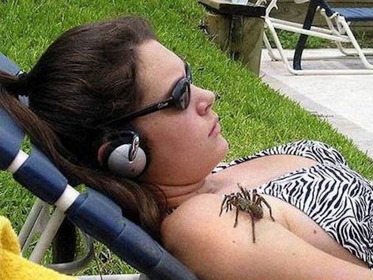
4 (girl lie on deck-chair / spider crawl up)

(discover, scream)

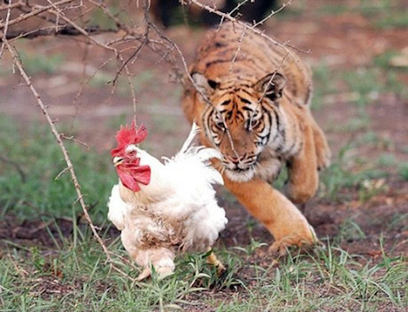
5 (hen pick corn, tiger appear)

(hen start running, see tiger)

The End

